Git Hands-on Lab 5 Report - Remote Repository (Pull & Push)

Objective
Execute steps involving clean up and push back to a remote Git repository.

Prerequisites
- Git installed
- GitHub account
- GitDemo repository
- Remote GitHub repository

Procedure
Step 1: Open repository
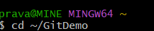
Step 2: Verify status
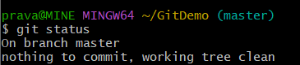
Step 3: List branches
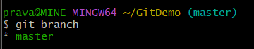
Step 4: Check remote
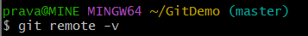
Step 5: Add remote if required
Step 6: Rename branch
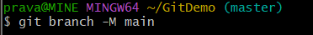
Step 7: Pull remote
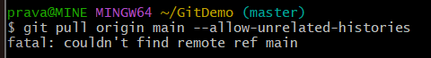
Step 8: Push repository
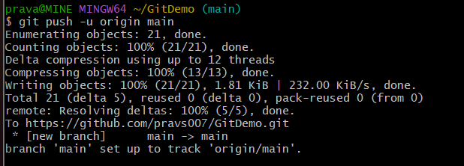
Step 9: Verify on GitHub
https://github.com/pravs007/GitDemo
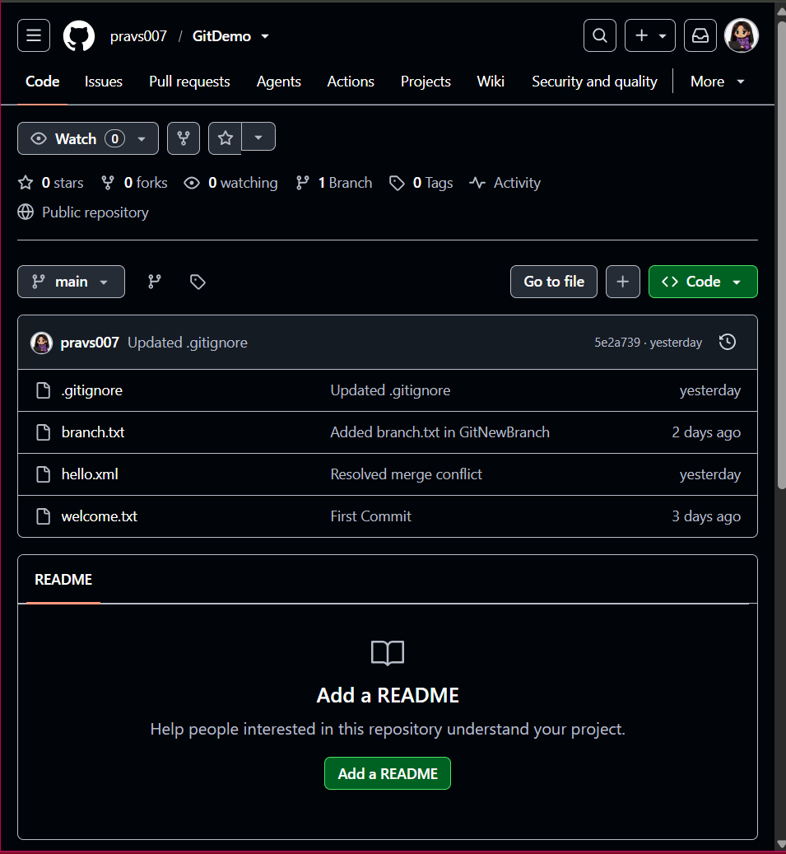

Result

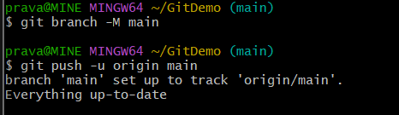

Conclusion
The local repository was successfully connected to GitHub, all commits were pushed to the remote repository, and the project was verified online.

